

321 Main Street, Woodbridge, NJ 07095 \ tel 732.750.0020 \ fax 732-658-5858 \ www.softwarems.com

Function Point Reference Card Order Form
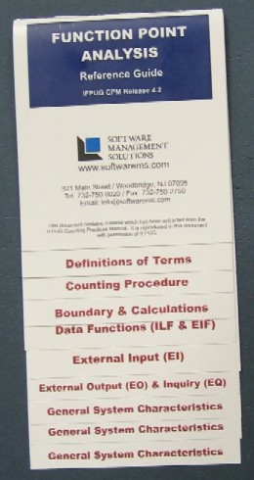
If you count function points then you must have a function point reference card that is easy to use. SMS has one of the most comprehensive and easy to use reference cards available in the industry. It is updated to reflect the Counting Practices Manual (CPM) Version 4.2 - Part 1 Rules with an accompanying trifold that summarizes Part 2 of the CPM. The rules reference card is a flip card with clearly marked taps for each section. The price per set (Part 1 & Part 2) is $7 which includes shipping and handling. Please complete the information below, print, sign, and fax (732-658-5858) or mail the form to SMS office.

1. Shipping Information

First Name Last Name
Title:
Organization:
Address:
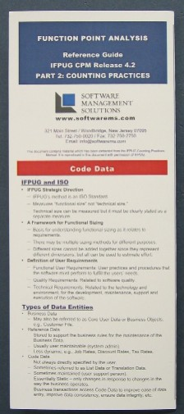
City: State: Zip:
Telephone: Email:

Quantity Ordered | Price per set | Total Order
 | $7.00 | $0.00
Shipping & Handling (if quoted) |  | $
Total |  | $0.00

5. Payment Method

Check Enclosed (make check payable to: Software Management Solutions)

VISA MasterCard American Express DISCOVER

Card #: Exp:

Name on Card: _

Zip code for card billing address: _

Signature:

Please print and sign this form and fax (732-658-5858) or mail to your contact at
Software Management Solutions

